**Digital Transformation: Enhancing IoT**

**-**

**driven Solutions for Smart Islands**

___________________________

Jamal

Sophieh

Expert

and Manager of Digital Economy Department (ICT ministry of Iran)

jsophieh@ut.ac.ir



Developing smart products and achieve sustainable Island through island

digital ecosystem



**Jamal Sophieh**

More than 20 years of experience in the ICT sector and in management and business field

PhD of Entrepreneurship and Business Creation (University of Tehran- Entrepreneurship Faculty)

University Instructor and Lecturer in University of Tehran and University of Shahid Beheshti (Tehran) for 5 years.

Senior Instructor of Digital Transformation and Digital Economy



Expert and Manager of Digital Economy Department (ICT ministry of Iran) for 5 years.

Coordinator and Expert of ITU Study Groups (Telecommunication Infrastructure Company- TIC.ir) for 3 years

Senior Analyst of Strategic and Comprehensive Planning (Telecommunication Infrastructure CompanyTIC.ir) for 5 years

Journalist and Analyst of ICT Specialized Magazines for 15 years

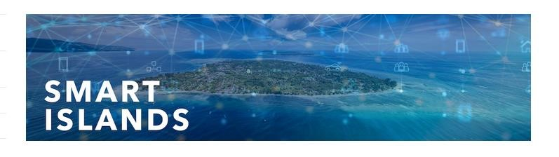

**Why Smart Islands are important?**

* *With about* [***11 percent of the world’s population living on islands****,*](https://newsroom.cisco.com/feature-content?articleId=1735451)
* *this becomes an issue not just for tourism, but also for the actual residents.*

# Smart Island definition

**A smart island is an island that demonstrates the following elements :**

* **smart governance, smart people, smart mobility, smart living, smart economy, and smart environment.**
* Being a smart island is also becoming synonymous with being green, sustainable, energy efficient, and climate resilient.
* Smart Island Initiatives define a smart island as *an insular territory that embarks on a climate resilient pathway, combining climate change mitigation and adaptation efforts, in order to create sustainable local economic development and a high quality of life for the local populations by implementing smart and integrated solutions for the management of infrastructure, natural resources and the environment as a whole, supported by the use of ICT, all while promoting the use of innovative and socially inclusive governance and financing schemes*.



# Smart Island definition

The term “smart islands“ is becoming almost as popular as “smart cities”.

Both are determined by what Streitz calls the “Smart-Everything Paradigm” (Streitz, 2021, 2022), a mainly technology-driven development encountered with smart cars, smart cities, and also smart islands.

It is mainly characterized by smart services based on data collected by a variety of sensors and combined with actuators as part of an Internet of Things (IoT) infrastructure, monitored and controlled by software using Artificial Intelligence (AI) or Machine Learning (ML), resulting in an increasing degree of automation and privacy infringements.

Humans are increasingly removed from being the “operator” and thus in control of their interactions and decisions in virtual and physical environments. Thus, we must ask – and answer - the question: “What kind of cities and islands do we want to live in?”

**Island’s Digital Transformation Goals**

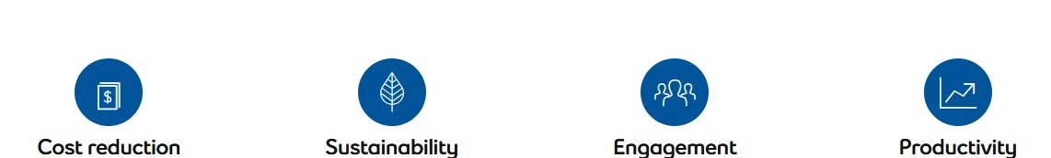

# Smart Island definition

The thematic coverage of smart islands encompasses a wide range of development sectors

➢smart governance and smart resource management

➢smart economy

➢smart mobility

➢smart environment

➢smart living and safe islands

# Smart Island definition

Based on the conducted analysis, the key areas of intervention for “smart islands” are identified below: **1. Smart governance and smart resource management**

1. e-public administration
2. ICT infrastructure
3. communication platforms for dialogue with citizens, and the civil and private sectors
4. smart planning of island development
5. encouraging social innovations
6. transparency of public data and information
7. integrated management systems for islands’ infrastructure and natural resources

# Smart Island definition

## 2. Smart economy

1. ecosystem for entrepreneurs
2. diversification of island economies
3. sustainable tourism development
4. territorial branding
5. development of creative and cultural industries and IT sector
6. expansion of opportunities for locally produced food
7. e-commerce
8. e-business and businesses networking
9. lifelong learning in line with the needs of the labour market and informatic literacy
10. development of skills related to smart specialization and entrepreneurship

# Smart Island definition

## 3. Smart mobility

1. infrastructure for clean island transport
2. alternative fuel infrastructure
3. walking, cycling and non-motorized transport infrastructure and services
4. digitalization of island transport systems
5. clean island transport vehicles
6. improving the mobility of the island population (not only tourists)
7. intermodal transport and better connectivity of islands and mainland
8. increasing the awareness of the local population and visitors about the need to preserve the environment and providing means for more rational use of resources

# Smart Island definition

## 4. Smart environment

Croatia’s islands: Making the most of their territorial capital through smart solutions 26 a) renewable energy sources and promoting self-sustainable islands

1. smart energy and water distribution systems and smart drainage
2. smart public infrastructure
3. smart buildings, homes and districts
4. smart waste management
5. control and monitoring of air, soil and water quality, noise reduction
6. smart and environmental management of industrial sites
7. smart measures for adapting to climate change
8. increasing the awareness of the local population and visitors about the need to preserve the environment and providing means for more rational use of resources

# Smart Island definition

## 5. Smart living and safe islands

1. high capacity broadband network
2. support to the development of e-citizens
3. digitalization in the field of health care (smart healthcare infrastructure)
4. and e-health services
5. smart educational infrastructure and development of educational platforms
6. social and inclusive infrastructure provision (including universal access for elderly and disabled)
7. protection, valorization and promotion of cultural heritage and cultural services
8. improvement in quality and security of public spaces
9. more effective development of a program to combat indigenous wildlife

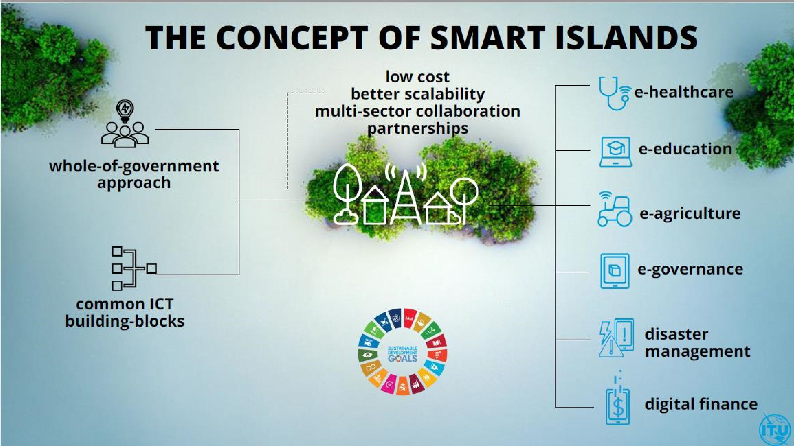

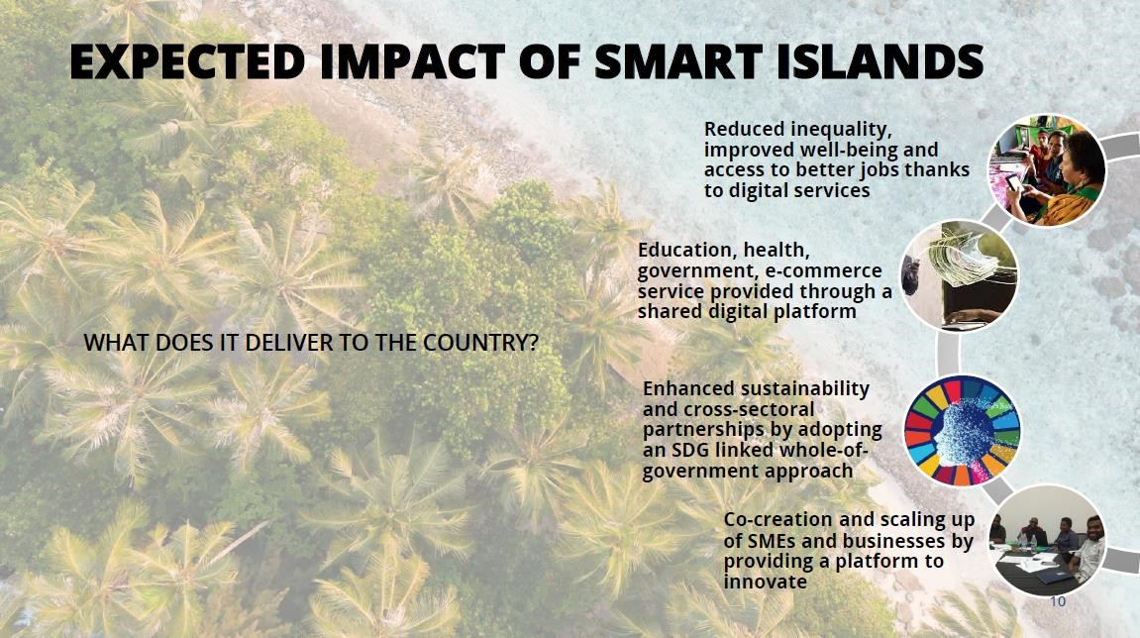

# Smart Islands Requires an Ecosystem Approach

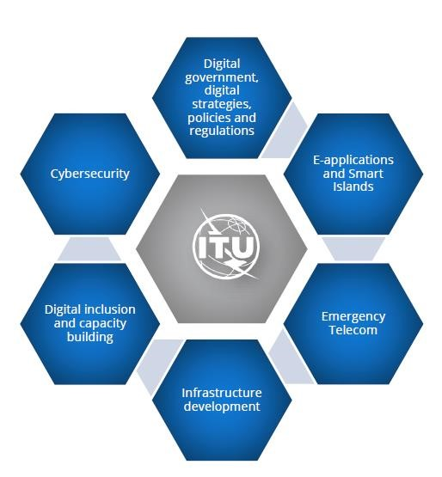

# Smart Islands Requires Long-term Partnerships

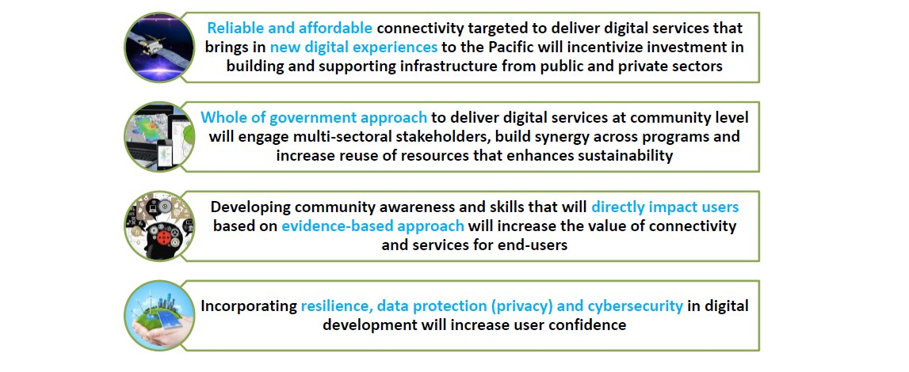

* Smart Islands is a programme that adopts an innovative approach to deliver connectivity and scalable and sustainable services to disadvantaged island communities.
* The Smart Islands programme aims at transforming rural and coastal communities and improving their well-being and livelihood by connecting them to a range of digitally enabled services.
* The programme, built on the ITU-led [Smart](https://www.itu.int/en/ITU-D/ICT-Applications/Pages/smart-village.aspx) [Villages](https://www.itu.int/en/ITU-D/ICT-Applications/Pages/smart-village.aspx) [initiative](https://www.itu.int/en/ITU-D/ICT-Applications/Pages/smart-village.aspx) piloted in Niger and being developed in Egypt and Pakistan, adopts an innovative approach to deliver connectivity and scalable and sustainable services to disadvantaged island communities.
* Small Island Developing States (SIDS) face a host of challenges, including geographic isolation, lack of human resources, low availability and quality of infrastructure, and vulnerability to external shocks. In remote areas and in outer islands access to information, government services, transport, health, finance, commerce and education needs prioritized attention.
* High costs of electricity and lack of affordable connectivity exacerbate the above challenges for SIDS. Not only does the absence of digital technology contribute to the digital divide, but it also deprives small island communities of the opportunity to leverage digital solutions to obtain better access to essential services.

# Solution

* The Smart Islands programme is based on a whole-of-government approach and it is demand-driven, user-centric, flexible, and focused on sustainability, scalability, and multi-sector collaboration.
* It is designed to manifest digital transformation at the community level, to leave no one behind. The initiative leverages the four pillars of (i) improving broadband connectivity (ii) making broadband affordable (iii) enhancing digital skills (iv) and providing digital services, to impact people's lives based on their local priorities.

# Solution

The Smart Islands programme will improve the provision of services in the following sectors:

* **Health:** the deployment of telemedicine and mHealth services to improve access to diagnosis, while also reducing the cost to the healthcare system. For example, mHealth programmes for diabetes prevention and control could be deployed on the basis of the ITU-WHO joint ‘Be Healthy Be Mobile’ initiative.
* **Education:** access to open and distance learning opportunities will enable capacity building for teachers and education administrators as well as providing equitable access to quality literacy, lifelong learning and skills programmes for children, youth, and adults. Local teachers could improve their qualifications and experiences of their students by using engaging education content, curated and uploaded on digital school units.
* **Farming:** e-Agriculture services can support efficient and productive farming capabilities among farmers, making rural communities more resilient from both economic and nutritional points of view. A specialized app could be provided that would help farmers detect and treat pests in a timely manner, based on the analysis of photos taken by conventional smartphones.
* **Multi-hazard early warning and response:** ICT systems for hazard risk monitoring, alert, and post-alert guidance and information. For example, a hurricane early warning system based on meteorological data analysis algorithms and messaging services.
* **Digital financial services:** provide access to much needed digital financial services, and accelerate financial inclusion goals.
* **Tourism and fishing:** support access to e-commerce and e-marketing to improve income opportunities and support livelihoods

# Small Islands into Smart Islands

Transformation of small islands into smart islands will bring about a positive change in local communities' quality of life by providing them with connectivity and new ICT-enabled services, while also promoting interoperability, cooperation, and holistic demand-driven response to SDG-related needs.

# Smart villages

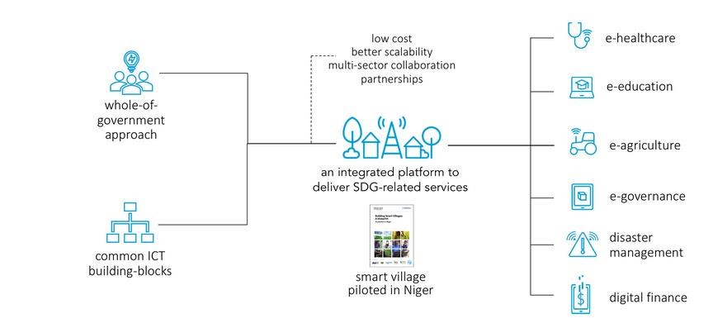

# Smartification And Sustainability’s Process

* Smart Data (need for)
* Next generation networks
* Smart mobility
* Smart Lights
* Energy efficiency / independency
* Green buildings
* Zero emissions
* Smart parking
* Smart transports
* Urban areas exploitation
* Smart citizens
* E-government
* Open gov
* Smart wastes

Main dimensions and sub-dimensions of the proposed KPI scheme for

Smart Sustainable Islands Index

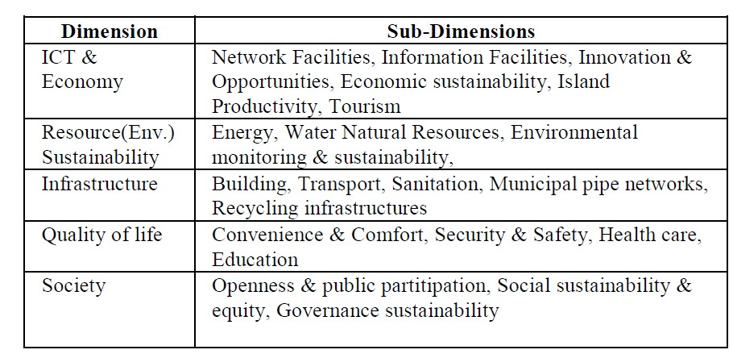

# Major Indicators of the proposed KPI scheme for Smart Sustainable Islands Index

## ICT & Economy

* Network Facilities
* Information Facilities
* Innovation & Opportunities • Economy & Production

## Resource Sustainability

* Energy
* Water
* Environment Monitoring
* Natural Resources

# Major Indicators of the proposed KPI scheme for Smart Sustainable Islands Index

## Infrastructure

* Building
* Transport
* Sanitation
* Municipal networks

# Major Indicators of the proposed KPI scheme for Smart Sustainable Islands Index

## Quality of life

* Convenience
* & Comfort
* Security
* & Safety
* Health
* Care
* Education

# Major Indicators of the proposed KPI scheme for Smart Sustainable Islands Index

## Society

* Openness & public partitip
* Social sustain & equity
* governance sustainability

**Smart Village: An IoT Based Digital Transformation**

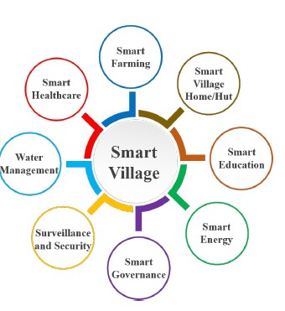

**Smart village design cycle**

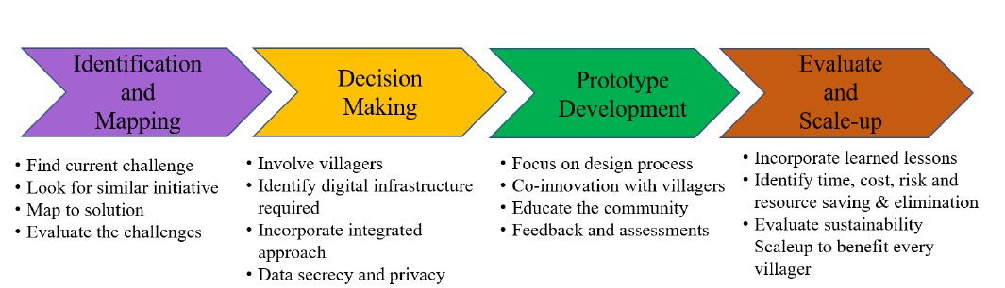

# Smart Village Key Aspects

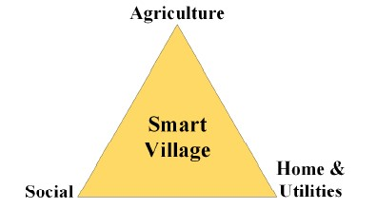

# Smart village

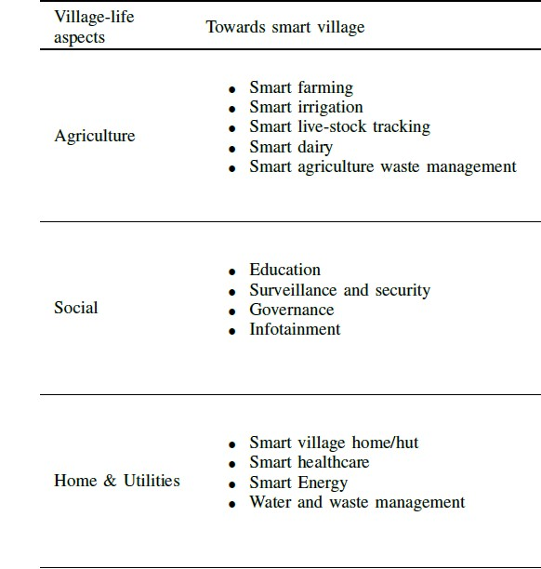

**IoT enabled digital transformation Digital transformation towards smart village**

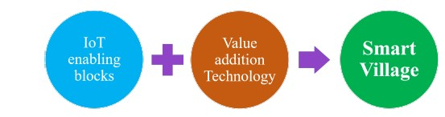

**Mapping of Smart Village Verticals to IoT Communication Technology**

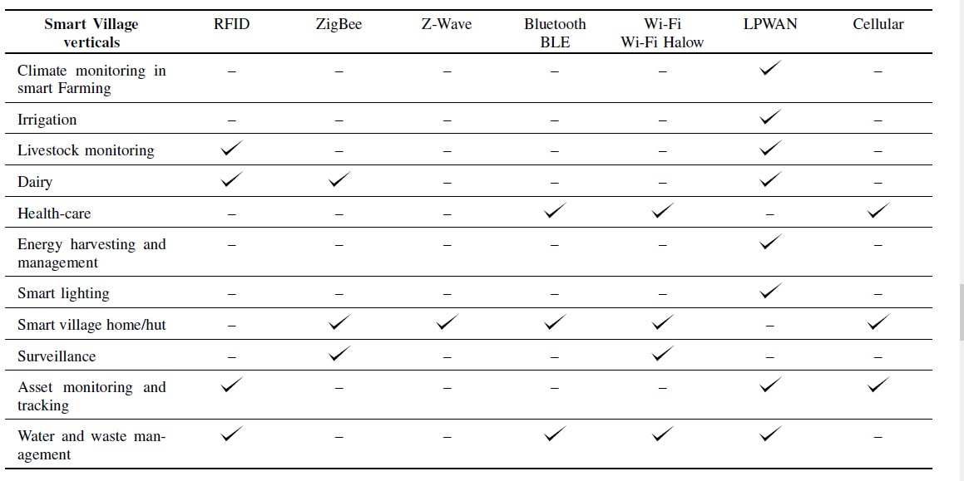

**The Evolution of IoT, from Smart Cities to Smart**

**Islands**

**The Evolution of IoT, from Smart Cities to Smart Islands**

**But can it work on islands?**

These metropolises are not the only ones that see the benefits of implementing smart strategies. The Samoa

Pathway report, issued at the Third International Conference on Small Island Developing States (SIDS) held in [Samoa in 2014 noted that “*access by Small Island Developing States to appropriate reliable, affordable, modern and environmentally sound technologies is critical to achieving their sustainable development objectives and in fostering an environment that provides incentives for innovation and entrepreneurship and that science, technology and innovation are essential enablers and drivers for sustainable development.*”.](https://news.itu.int/samoa-pathway-mid-term-review-how-tech-is-helping-small-island-countries/)

**The Evolution of IoT, from Smart Cities to Smart Islands**

* A large focus of this conference revolved around the availability and affordability of ICT (Information and Communication Technology) networks throughout the 52 countries and territories making up the group of SIDS. Significant progress has been made on this front across the small islands since the 2014 conference.
* Mobile broadband coverage had risen from 50% of the SIDS population in 2014 to 85% in 2019, while the cost of mobile data dropped from being 15% of total Gross National Income (GNI) to 8%. Regional regulatory bodies, such as ECTEL (the Eastern Caribbean Telecommunications Authority) have been set up to help recommend policies, procedures and guidelines in key areas surrounding ICT development within their member states.
* Islands, as the countries which feel the brunt of climate change effects due to their geographical isolation, lack of resources and extensive coastlines, stand much to gain by arming themselves with integrated data collection, analysis and response systems in all aspects. Even here in Grenada, local companies have been working towards the incorporation of sensor technology to track things like water consumption and weather patterns.

**The Evolution of IoT, from Smart Cities to Smart Islands**

* At this point, the main constraints facing island development are digital skills and awareness along with financial and human resources. Projects like the Smart Islands Initiative led by the EU are focused on improving island life through [“sustainable,](https://www.smartislandsinitiative.eu/en/index.php) [integrated](https://www.smartislandsinitiative.eu/en/index.php) [solutions](https://www.smartislandsinitiative.eu/en/index.php) [that](https://www.smartislandsinitiative.eu/en/index.php) [make](https://www.smartislandsinitiative.eu/en/index.php) [the](https://www.smartislandsinitiative.eu/en/index.php) [most](https://www.smartislandsinitiative.eu/en/index.php) [out](https://www.smartislandsinitiative.eu/en/index.php) [of](https://www.smartislandsinitiative.eu/en/index.php) [islands’](https://www.smartislandsinitiative.eu/en/index.php) [competitive](https://www.smartislandsinitiative.eu/en/index.php) [advantages.](https://www.smartislandsinitiative.eu/en/index.php)” Focused on the islands surrounding Europe, as well as the EU’s outlying island dependencies, the Union sees small islands as the perfect petri dish to test multiple projects in resource and infrastructure management which can later be transplanted into mainland mountain regions or scaled up to the typical urban context. This all shows that, given the right amount of attention and financial support, island states too can become global leaders in the IoT era.
* So what’s next? As multinational organizations continue to emphasize Small Island development and as governments begin to prioritize technological advancement, island populations must prepare both their ICT workforce to help develop and manage the technology, as well as their collective mindsets to adapt to the societal and infrastructural changes that will come with IoT implementation. Progress is consistent, and the future is integrated.

# The EU Initiative “Smart Islands” Islands

.

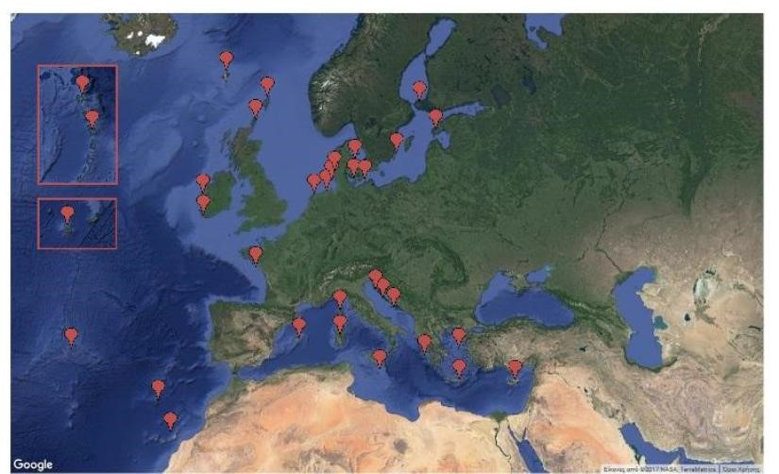

**Are Smart Islands the next step to EU sustainability success?**

* *Running an island is hard work. Sure, some like Ibiza thrive as vacation destinations and profit from tourism, but due to their insularity, many are heavily dependent on energy—especially fossil fuels.*
* *Islands are also faced with the challenge of maintaining (or creating) a sustainable local environment and ecosystem while still managing issues such as high transportation costs and pollution.*

**Are Smart Islands the next step to EU sustainability success?**

* *With about* [***11***](https://newsroom.cisco.com/feature-content?articleId=1735451)[***percent***](https://newsroom.cisco.com/feature-content?articleId=1735451)[***of***](https://newsroom.cisco.com/feature-content?articleId=1735451)[***the***](https://newsroom.cisco.com/feature-content?articleId=1735451)[***world’s***](https://newsroom.cisco.com/feature-content?articleId=1735451)[***population***](https://newsroom.cisco.com/feature-content?articleId=1735451)[***living***](https://newsroom.cisco.com/feature-content?articleId=1735451)[***on***](https://newsroom.cisco.com/feature-content?articleId=1735451)[***islands****,*](https://newsroom.cisco.com/feature-content?articleId=1735451) *this becomes an issue not just for tourism, but also for the actual residents.*
* *As the EU looks to be a driver in terms of a low carbon economy, islands in Europe are becoming more aware of their role to serve as inspiration for sustainable, integrated solutions that “make the most out of islands’ competitive advantages,” according to the* [***Smart***](http://www.smartislandsinitiative.eu/en/index.php)[***Islands***](http://www.smartislandsinitiative.eu/en/index.php)[***Initiative****.*](http://www.smartislandsinitiative.eu/en/index.php)
* *this new efforts inspired by Smart Cities and Communities shows how Europe’s islands may play a vital role in helping Europe transition into a low carbon and sustainable economy.*

**Rethinking ‘Smart’ Islands: Toward Humane, Self-Aware, and Cooperative Hybrid Islands.**



**Participatory Innovation Model.**

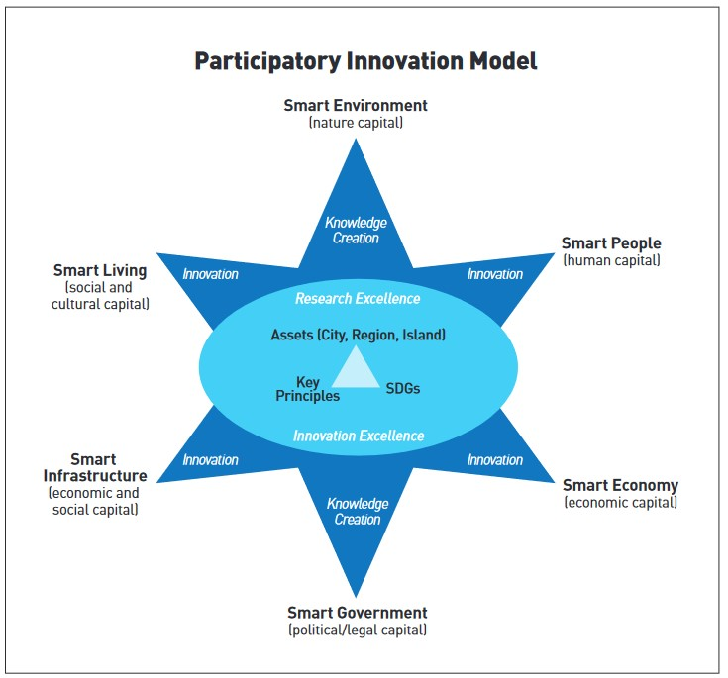

**Examples of Big Topics** 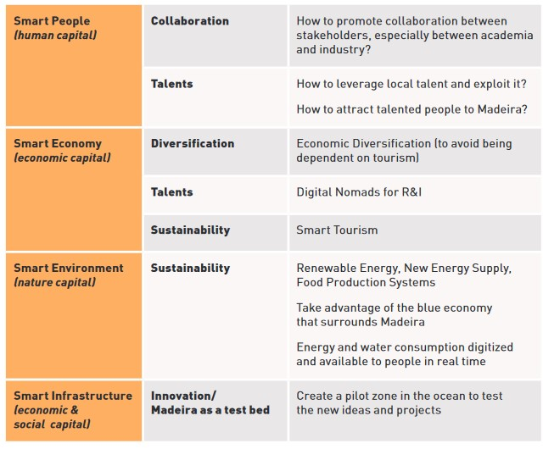

## Empowerment-Coherence Concept

**Data sources**

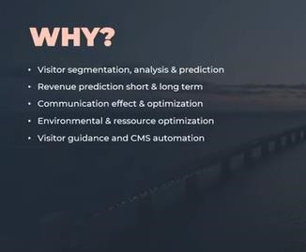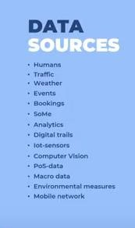

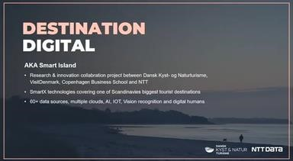

Watch here: <https://www.youtube.com/watch?v=Xo4AGuo0f2M>

